**Forward Characteristics of Diodes; Clipping Circuit**

EE 3310L

Fall 2021

**Celeste Hicks**

Submitted to TA: C. Hicks Monday 4:50PM

Date of Experiment: 10/19/21

Date of Submission: 10/25/21

1. **Introduction**

A diode is a simple semiconductor device that only allows current to flow in one direction (from the anode to the cathode), and only when the voltage at the anode is more positive than the voltage at the cathode. In this condition, the diode is considered forward biased. In the “constant drop” model, a diode that is forward biased will have a constant voltage drop. This voltage drop is approximately 0.7 V for silicon rectifier diodes but changes with different diode types, like LEDs.

Diodes can also be used to build a diode clipper circuit. This circuit contains two diodes with opposite polarities in parallel with each other. This results in the output voltage (measured across the parallel diodes) being significantly limited when the input voltage magnitude suddenly spikes. This circuit works to protect sensitive electronic components or instruments from large magnitude voltage surges or swings [1].

This experiment aims to measure and plot the forward voltage drop versus current for two different diodes as well as investigate the effectiveness of a diode clipper circuit [1].

1. **Experimental Methodology [1]**

First, circuit one shown in Figure 1 below was built. A DC power supply set to its minimum voltage setting was attached in series with a 1N4001 rectifier diode and a 1 kΩ ¼ W resistor.

Figure 1 - Circuit one schematic.

The negative lead of a digital multimeter was connected between the diode and resistor. To measure the current, the positive lead was connected after the resistor, and the absolute value of the voltage across the resistor was measured and divided by 103. To measure voltage across the diode, the positive lead of the multimeter was connected before the diode.

The current through the circuit was measured while the power supply voltage was slowly increased. When the current reached 20 µA, the forward diode voltage drop was measured and recorded as VD. This process was repeated at currents of approximately 0.050 mA, 0.10 mA, 0.20 mA, 0.50 mA, 1.0 mA, 2.0 mA, 5.0 mA, 10.0 mA, and 20.0 mA. The actual currents that the voltages were measured at were recorded as ID. Then, the diode was replaced with a red LED and this process was repeated at the same approximate currents, recording the voltage across the LED as VLED and the actual currents as ILED. Also, the current at which light was first visible from the LED and the current at which the LED was sufficiently bright to serve as a “power on” indicator were both recorded.

Next, circuit two shown in Figure 2 below was built. Two 1N4001 rectifier diodes were connected in parallel with each other and with opposite polarities, and this parallel combination was then connected in series with a function generator set to a 1 kHz sinusoid at the minimum amplitude and with a 1 kΩ ¼ W resistor. An oscilloscope was used to measure and view the input voltage of the function generator on one channel and the output voltage across the parallel diodes on another channel.

Figure 2 - Circuit two schematic.

The voltage of the function generator was gradually increased until clipping of the output voltage waveform was just noticeable. The peak-to-peak voltage of the output voltage waveform was recorded. Then, the function generator’s voltage was increased to its maximum, and the peak-to-peak voltages of both the input and output voltage waveforms were recorded. The diodes in the circuit were then replaced with green LEDs, and this process was repeated.

VD and VLED were both plotted versus their currents (ID and ILED) on the same graph twice, with one plot having a logarithmic y-axis for current and a linear x-axis for voltage, and the other plot having linear axis scaling for both axes. Finally, the ratio in dB between the maximum peak-to-peak generator voltage and the peak-to-peak voltage of the clipped output waveform was calculated for circuit two with diodes and for circuit two with LEDs.

1. **Results and Description**

Table 1 below shows the measured forward diode voltage drop at each of the tested currents from circuit one.

Table 1 - The measured diode voltages and currents from circuit one.

|  |  |
| --- | --- |
| **ID (mA)** | **VD (V)** |
| 0.0209 | 0.449 |
| 0.0528 | 0.481 |
| 0.0993 | 0.501 |
| 0.199 | 0.527 |
| 0.499 | 0.561 |
| 1.00 | 0.589 |
| 2.03 | 0.62 |
| 5.02 | 0.66 |
| 10.0 | 0.69 |
| 20.1 | 0.721 |

Table 2 below shows the measured voltage drop across the LED at each of the tested currents in circuit one.

Table 2 - The measured LED voltage drops and currents from circuit one.

|  |  |
| --- | --- |
| **ILED (mA)** | **VLED (V)** |
| 0.0216 | 1.699 |
| 0.051 | 1.73 |
| 0.100 | 1.754 |
| 0.203 | 1.778 |
| 0.502 | 1.811 |
| 1.00 | 1.85 |
| 2.01 | 1.89 |
| 5.00 | 1.95 |
| 9.99 | 2.03 |
| 20 | 2.15 |

Table 3 below shows the measured currents through circuit one with an LED when the LED just began to light up and when the LED was sufficiently bright to serve as a “power on” indicator for an electrical appliance.

Table 3 - The currents at which the LED light was just visible and at which the LED was sufficiently bright from circuit one.

|  |  |
| --- | --- |
| **Current (mA) at which the LED:** | |
| **just lights up** | **is sufficiently bright** |
| 0.156 | 11.2 |

Table 4 below shows the peak-to-peak voltages of Vout and Vsource in circuit two when clipping of the Vout waveform just began to appear and when Vsource was set to its maximum and there was “hard” clipping of the Vout waveform.

Table 4 - Vout and Vsource voltages when clipping just started to appear and when "hard" clipping was present for circuit two with diodes and with LEDs.

|  |  |  |  |
| --- | --- | --- | --- |
|  |  | **Peak-to-Peak Voltage (V) at which:** | |
|  |  | **clipping just starts to appear** | **"hard" clipping is present** |
| **With Diodes** | **VOUT** | 1.0 | 1.76 |
| **VSOURCE** | - | 19.6 |
| **With LEDs** | **VOUT** | 3.76 | 5.12 |
| **VSOURCE** | - | 20.0 |

Table 5 below shows the calculated ratios of Vout/Vsource in decibels for the hard clipped waveforms of circuit two with either diodes or LEDs. The calculations for these values are shown in Figure 5 in Appendix A.

Table 5 - The ratios of Vout/Vsource in decibels for circuit two with diodes and with LEDs.

|  |  |
| --- | --- |
|  | **VOUT/VSOURCE ratio in dB  for hard clipped circuit** |
| **Diodes** | -20.93 |
| **LEDs** | -11.84 |

Figure 3 below shows the first plot of both VD vs. ID (from Table 1) and VLED vs. ILED (from Table 2). The current (y) axis is on a log scale while the voltage (x) axis is on a linear scale.



Figure 3 - Plot of diode voltage vs. current and LED voltage vs. current, with a logarithmic y-axis (current) and a linear x-axis (voltage).

Figure 4 below shows the second plot of VD vs. ID (from Table 1) and VLED vs. ILED (from Table 2). This plot has linear axis scaling for both the y-axis and the x-axis.



Figure 4 - Plot of diode voltage vs. current and LED voltage vs. current, with linear axes scales.

1. **Discussion**

Based on the curves in the plots shown in Figures 3 and 4, the constant-drop voltage of the 1N4001 silicon rectifier diode was estimated to be approximately 0.7 V, and the constant-drop voltage of the LED was estimated to be about 2.0 V. These estimates were made based on the approximate final voltages that the diodes appeared to stabilize at for most of the larger currents tested.

The diode clipper circuit (circuit two) caused the waveform of Vout to be very hard clipped when Vsource was turned up to its maximum voltage. The peak-to-peak voltage of the hard clipped Vout waveform was significantly lower than the peak-to-peak voltage of the Vsource waveform, and the ratio of Vout/Vsource in decibels was a large magnitude for both the rectifier diodes and the LEDs. This shows that the diode clipper circuit worked as intended to limit large peak-to-peak magnitude voltage swings in Vout, with the rectifier diodes limiting Vout to a smaller magnitude than the LEDs did.

1. **Summary and Conclusions**

In this experiment, a DC circuit with a silicon rectifier diode and then a LED was constructed and the voltage drop across the diode was measured at several different currents. These voltages were plotted versus current to determine the approximate constant drop voltage for each diode. Next, a diode clipper circuit was constructed with two silicon rectifier diodes and then two LEDs, and the maximum peak-to-peak output voltage was measured and compared to the input voltage [1].

The plots of the diodes’ voltage versus current showed an approximate constant voltage drop of 0.7 V for the silicon diode and 2.0 V for the LED, and the measured voltages from the diode clipper circuit showed that the circuit was very effective at limiting large magnitude voltage swings.

**References**

[1] Tritschler, Joe. "Forward Characteristics of Diodes; Clipping Circuits." N.p., n.d. Web. 19 Oct 2021.

**APPENDIX A**

Calculations

Figure 5 below shows the calculations for the ratios of Vout/Vsource in decibels for circuit two with diodes and with LEDs.

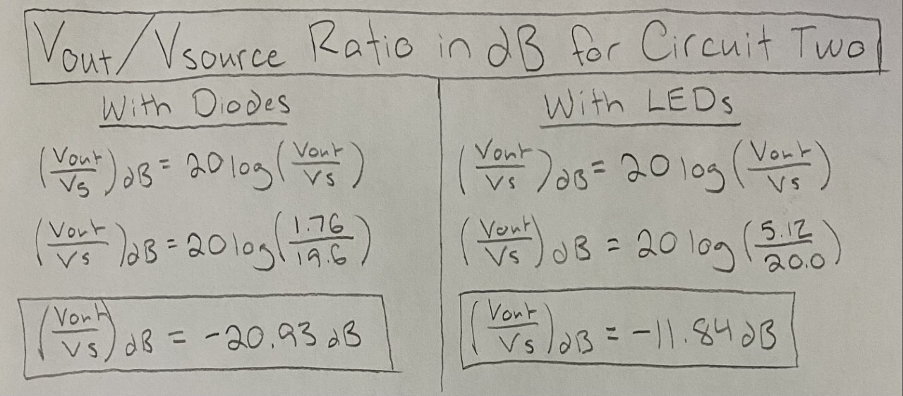

Figure 5 - Calculations for the ratios of Vout/Vsource in decibels for circuit two with diodes and with LEDs.